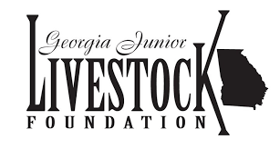

Georgia Junior Livestock Foundation
Community Upload Page

Parents are encouraged to upload candid pictures of their child which occur during the Georgia Junior National Livestock Show. Pictures can include: show ring, wash rack, awards, prep area, stall area, etc. This includes the state shows (sheep and goat) which occur during the Georgia National Fair. The candid pictures will be used throughout the GJLF yearbook. Uploading candid pictures does not guarantee that all pictures will be used. We will make all attempts to create a yearbook with as many candid shots as possible.

Step 1 - Go to http://community.lifetouch.com/ and set up an account (email address and password will be required)

Step 2 - Use access code IDWDIX to upload to Georgia Junior Livestock Foundation Yearbook

Step 3 - Upload images for Georgia Junior Livestock Foundation using these guidelines.
Browse for your images below. Follow these guidelines:
- The length of the file name should not exceed 25 characters.
- Name your file using characters and/or numbers.
- Upload up to 5 files at a time.
- Each file size should not exceed 10 MB.
- Do not use *, &, ', or other special characters when naming files.
- Files must be in a .jpeg format.
Upload time will vary depending on your internet connection. Please wait until you see the Upload Confirmation page before you upload more files.

